**Lab 4:**

Unit Testing

**Exercise 1**: (7 marks)

Assuming you are assigned to conduct the component test for the method below, please design and create the minimum component test case (unit test case) needed to achieve 100% statement coverage and 100% decision coverage.

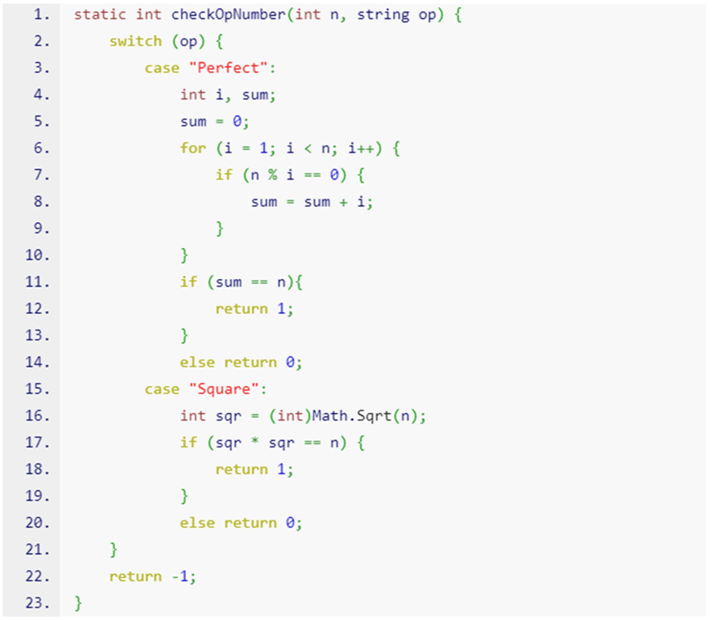

Use the given Template for unit testing, complete the lab 4 that apply unit testing.

**Exercise 2:** Write code and unit test with Junit, based on the demo project. (3 marks)